**Task 1 - Ring Defect Detection**

**Flowchart**

Here is a flowchart illustrating the defect detection algorithm.

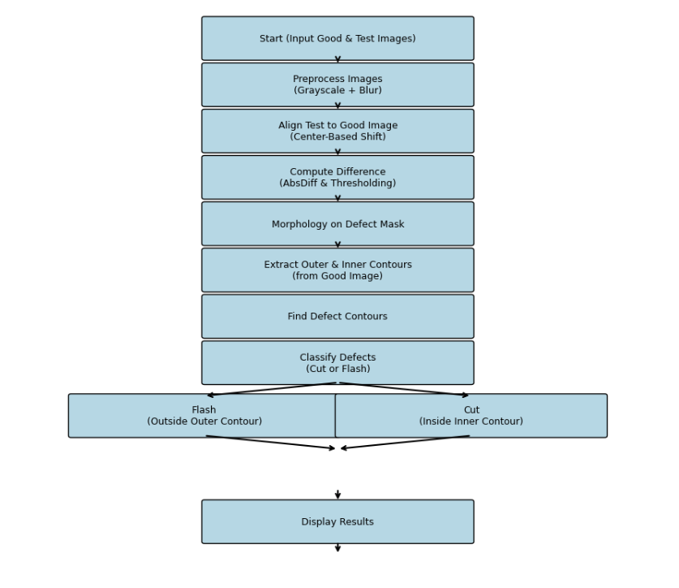

**Basic Algorithm to Find Defects**

The algorithm for finding defects is a three-step process that compares a test image to a known good image without relying on precise pixel alignment. It works for different diameters and positions.

1. **Preprocessing**: First, convert both the good image and the test image to **grayscale**. Apply a **binary threshold** to both images. This separates the black ring from the white background, making the contours easier to detect.
2. **Contour Analysis**: Find the two main contours in the preprocessed images: the outer edge of the black ring and the inner edge of the white hole. These contours are essential for the next steps. For a good image, these contours should be nearly perfect circles.
3. **Defect Detection**: A defect is a significant deviation from the perfect shape of a circle. Compare the properties of the test image's contours to those of the good image. A difference in shape, such as a bump or a cut, will indicate a defect.

**Localizing the Defect**

To localize a defect, you need to identify where the shape of the test image's contours deviates from the good image's contours.

1. **Find Defect Contours**: After detecting a defect, calculate the **absolute difference** between the aligned good and test images. Thresholding this difference image will create a mask that highlights the defective regions.
2. **Draw Bounding Boxes**: Find the contours of these defective regions within the mask. Then, draw a **bounding box** around each of these defect contours. This visually pinpoints the exact location of the defect on the original image.

**Classify the Defect to Flashes and Cut Marks**

Defects are classified based on which part of the ring's shape has been altered. The key is to use the **circularity** metric, which measures how close a shape is to a perfect circle (a perfect circle has a circularity of 1.0).

1. **Flashes**: A "flash" is a protrusion on the **outer edge** of the ring. This type of defect causes a significant **decrease in the circularity of the outer contour**, while the inner contour remains relatively unaffected.
2. **Cut Marks**: A "cut" is an indentation or break on the **inner edge** of the ring. This defect causes a significant **decrease in the circularity of the inner contour**, while the outer contour remains largely unchanged.

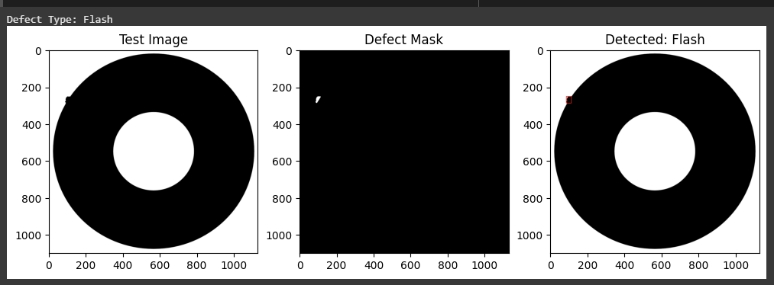

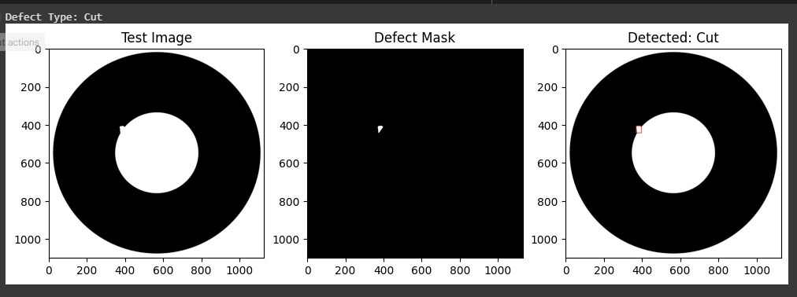

It clearly states that I haven't yet met all the conditions for this only problem. I will update this file once I done it.